## 1 Introduction

* 1. erview:

A Visa slot management project is a system that is used to track and manage the availability of visa slot which are appointment that are requied for certain visa appliction.

* 1. purpose:

It might be used by a government agency or a visa processing center to schedule and manage appointment with applicants.

## 2 Problem Definition & Design Thinking

2.1 Empathy map

## Screenshot (3)

2.2 Ideation & Brain storming map

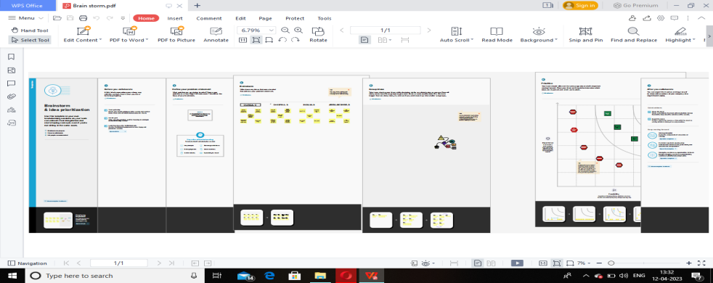

## 3 Result

3.1 Data Model:

|  |  |
| --- | --- |
| Object name | Field in the object |
| Obj 1  custom | |  |  | | --- | --- | | Field lable | Data type | | passport | text | | visa | text | |
| Obj 2  custom | |  |  | | --- | --- | | Field lable | Data type | | payment | text | | Reschedule/ cancel | text | |

3.2 Screenshot & Activity

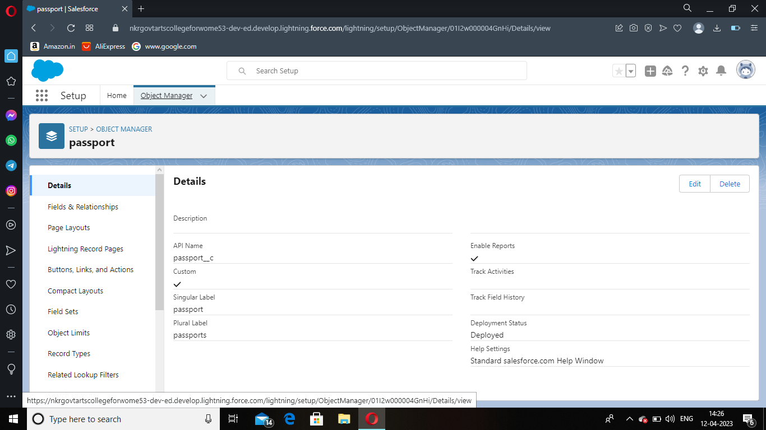

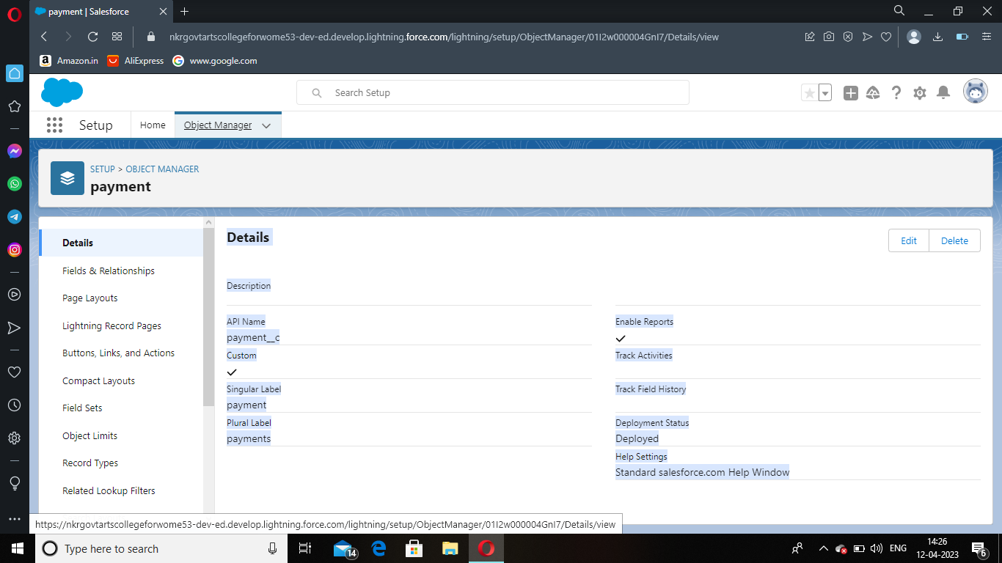

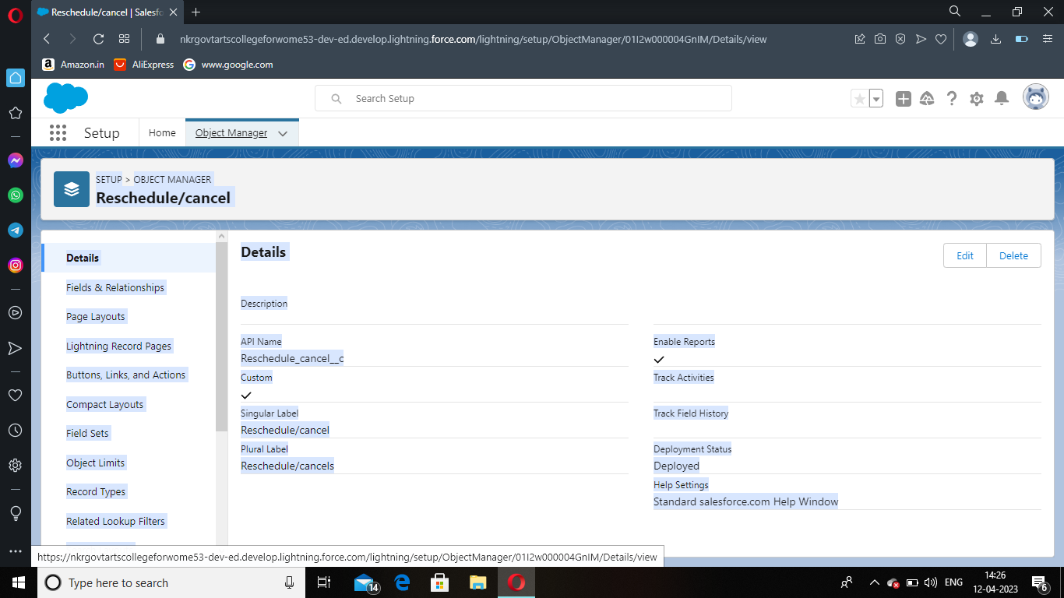

1. Trail head Profile Public URL

Team Lead : htpps://trailblazer.me/id/durgac3

Team Member 1 : https://trailblazer.me/id/indhus

Team Member 2 :htpps://trailblazer.me/id/ssdheepika

Team Member3: https://trailblazer.me/id/jlakshmi67

## Project Report Template

## Advantages & Disadvandage

Filling the application from is very easy home while you are traving .

Passangers cant go to other countries

## Aplication

Esay to be a visa to book a slot but is very esay way to the porsees

## Conclusion

The avarege wait for a visa appointment in the US consulate at new delhi is 522 days for visitor visa.

## Future scope

The wait is overwhelming long get appointment for us visa .